**Jezarelle T. Lanzaderas**

Cagayan de Oro, Misamis Oriental 9000

Contact Number: +63975-625-9665

Email: [lanzaderas.jezarelle@gmail.com](mailto:lanzaderas.jezarelle@gmail.com)

March 19, 2021

**Dr. Josephine C. Visande**

Director, Admission and Scholarship

University of Science and Technology of Southern Philippines

Cagayan de Oro, Misamis Oriental 9000

Dear Ma’am,

Good Day!

It has long been a dream of mine to study BS in Architecture at the University of Science and Technology of the Southern Philippines, so I am delighted to submit my formal application to enter the freshman class for the academic year 2021-2022. I chose to apply to USTP after conducting research to find the best BS in Architecture program, as I am dedicated to preparing for a successful career in this area. USTP is, without a doubt, my first preference.

My academic experience and achievements have given me the necessary tools for success. In the national competition for students designers, I was awarded first place. In addition, I was awarded first place in the Philippines Painting Competition. These activities qualify me for USTP. I'm confident that at your school, I'll be able to continue my winning streak. I am sure that I will be a valuable asset to the university.

As a student pursuing a BS in Architecture at the University of Science and Technology of the Southern Philippines, I am excited to begin my college education and am dedicated to academic excellence. This letter comes with all of the necessary documents, and my official test scores and transcripts will be mailed directly to you.

Thank you very much for taking the time to read this and for considering my request. I'm looking forward to getting a letter from USTP confirming my acceptance. You can reach me at the phone number and email address mentioned above if you have any questions.

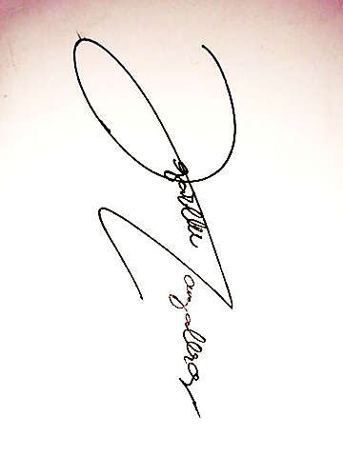

Sincerely,

Jezarelle T. Lanzaderas